Vocabulary
Adhesion precipitation run off infiltration
Cohesion Transpiration porosity permeable
Surface tension impermeable closed system open system
Hydrogen bonding limiting factor nitrates pH
Polarity density of ice capillary action
Solvent heat capacity abiotic biotic factor
Solute Solution Water cycle dissolved
Biosphere atmosphere hydrosphere geosphere
Evaporation condensation fecal E coli sewage treatment
Water quality conservation reservoirs aquifer
- What is the percentage of freshwater verse salt water?
97% Salt Water 3% Freshwater
- How much of the freshwater is locked in ice? 2% is locked in ice. Antarctica holds most of this 2%
- How much is available to use from surface and groundwater? 1%
- What is infiltration and how does nature use it to clean water? Infiltration is the process of water moving down through rock and soil. Nature used this process to filter out impurities so the water in the aquifer is relatively clean.
- What is the continuous movement of water on above or below the Earth called? Water Cycle
- What two forces influence the water cycle? Energy from the Sun and Gravity
- Why is that ground water can stay for thousands of years before returning to the water cycle? The sun’s energy cannot reach the ground water so there is no evaporation causing it to stay in this reservoir for long periods of time.
- What part of the water cycle does the sun influence? Evaporation
- How do plants interact with the water cycle? Transpiration is when plants lose water to evaporation through their leaves.
- What state of matter is the water in when it is evaporated? Gas
- What state of matter is the water molecule when it is condensing? Liquid
- What is different between runoff and infiltration? Run off is water flowing along the surface in streams and river. It often comes from melting snow packs or precipitation. Infiltration is when water moves down through the ground to form the aquifer.
- 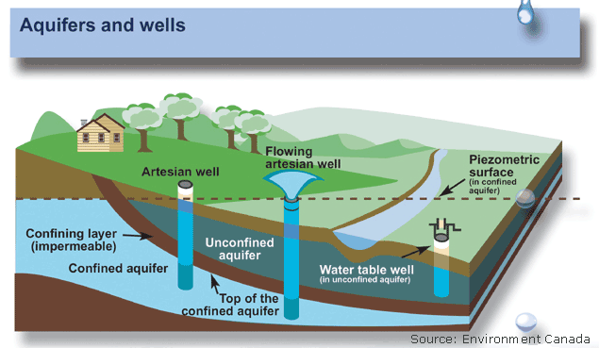How can well water be contaminated? Water is the universal solvent. If chemicals or pollutants get in to the soil they can eventually work their way down into the aquifer where wells draw their water from.
- What is the difference between porosity and impermeable material? How does nature use to make a confined and unconfined aquifer? Porosity is spaces and cracks in the rock where water can be move or be stored. Impermeable means to have little to no pores which acts more as a dish holding the water. Clay and shale act as an impermeable layer forming groundwater reservoir.
- Why is that water is never truly pure in nature? Explain Again Water is the universal solvent and so it always contains dissolved substances in it from nature.
- How does spring runoff recharge groundwater and influence well water levels? Snow melt and precipitation runs down from high elevations and then seeps down the soil refilling the aquifer and well levels go up.

- What human activities drain aquifers? Where do we use most of our water in American Fork? Agriculture and industry. American Fork gets its water wells dug into the North Utah County aquifer as well as from precipitation and the AF river.
- What country in the world uses the most water? The United States
- 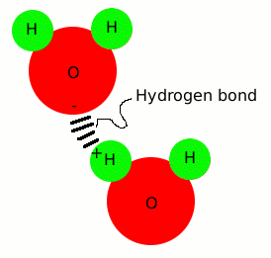Name 5 ways that communities can deal with water shortages through conservation.
Water Lawns less, shorter showers, don’t leave it running while you brush your teeth. Laws and regulations on water and water quality.
- Draw the water molecule and properly label the hydrogens and oxygen with their charges.

- What is polarity and how does it allow water molecules to dissolve other substances in solution? Hydrogen molecules are positive and Oxygen Molecules are negative . A polar molecule is one that is slightly charged on both ends. Many substances can be dissolved in solution because the water molecule can pull other substances apart as it is attracted to the opposite charge.

- What is pH mean? Draw the two ions. H+ and OH- ions come from a water molecule that has been separated. pH means how acidic or basic a solution is. Acids have more H+ and Bases have more OH-
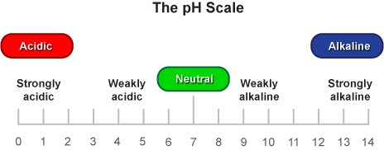
- Label the pH scale
What is normal pH?

Acidic normal Basic
- What is the difference between adhesion and cohesion? Adhesion is when the water molecule attaches to another surface such as a leaf or side of a glass cup. Cohesion is when the water molecule attaches to another water molecule.

- What are hydrogen bonds? Explain how these bonds help cohesion. What happens to the bonds in surface tension? Hydrogen bonds are bonds made between the negative charge of the Oxygen and the positive charge of the Hydrogen. This bond allows water molecules to stick together and flow. Hydrogen bonds can stretch slightly allowing the water to dome up over a penny or bend under the weight of a water strider.

- What force is moving water up the stem. Explain how these two forces allow this to happen. Capillary action is when water molecules move up a stem due to adhesive and cohesive forces as well as water pressure.

- Why does water have a high heat capacity? How does it regulate climate? Water can store large amounts of heat between 0 degrees and 100 degrees without changing phases. This means that it takes a long time for it to heat up and a long time for it to cool down verses other materials. This ability to store heat helps Oceans and Large Lakes to regulate the world’s climates.

- List the nine water quality factors we look for when testing water, why do we need to monitor and protect our fresh water resources in our community? Explain
Heavy Metals- Industry. Abnormalities
Fecal Coliform Bacteria- disease
Nutrients- pesticides and fertilizers- algae growth
pH- how acid or basic the water is. Industry, agriculture, C02 levels
Dissolved Oxygen- necessary for aquatic organisms to live and reproduce
Water clarity- how clear the water is. Run Off debris
Macroinvertibrates- aquatic bugs quality tells how healthy the water is
Salinity- amount of salt or dissolved substances. Most aquatic animals have a narrow range of tolerance
Water temperature- cooler temperatures more oxygen. Higher temperature less oxygen more algae growth.
We monitor water quality to insure that fresh water resources are not dangerous to use.
- If the pH goes beyond 6.5-9 what will happen to the living things in a freshwater ecosystem? If pH changes many aquatic organisms will die.
- Why must communities treat and clean their drinking water after their citizens have used it using sewage treatment plants? Communities treat storm and waste water in sewage treatment plants to help clean up the water and put it back into the environment for use to reuse. Chemicals and bacteria are used to do this.

- Why is fresh clean water our most precious natural resource on the planet? We have only 1% of the world’s water available for use for all living things to share and survive. All living things need water to live. With so many using it and so little really available to is our most vital and important resource for life on our planet

- 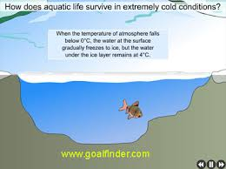Explain how ice is less dense that water? Explain how it protects freshwater lakes from freezing solid. Water freezes into a six sided crystalin shape that traps air in the middle of the ring of water molecules. This allows ice to expand when frozen. Nature used this phenomena to insulate freshwater lakes from freezing solid and forms a protective barrier to aquatic organisms below.

- What is our main watershed in Utah county? Why
All of our streams run to Utah Lake forming our watershed which is our lowest collecting point for water in Utah county. With several hundreds of thousands of people who use this water we would drain Utah lake in 2 months of its fresh water . It is important to protect and monitor water usage from inlets that lead to the lake to ensure that it is clean.

