Name ___________ Class ________ Changes in Climate Notes
- Weather vs. Climate
  - Weather is defined as: the _____________ of the _____________________________ at any given time
    - Weather is a ______________ ______________ measurement of what’s happening in the atmosphere
  - Climate is defined as: the _________________ of all the ________________ __________ that describes a place or region
    - Climate is the _________________________________ of all the weather information over a _____________ ___________________ of time (i.e. many years, decades, centuries or even longer)
- Measuring Climate
  - Recent climate data is available through records of ______________ ___________________________
  - Past climate data is collected through _____________________ data including:
    - Sea floor studies: studying ________________________ in the sea floor can tell us about earth’s _________________________ over ______________________ of years
    - Glaciers: Glaciers contain detailed records of _______________________, ___________________, _______________________ of the atmosphere, ___________________ (i.e. ash, dust, pollen, pollution etc.)
    - Tree rings: Trees usually _______ a ring to their trunk each year. By studying the ____________ of the rings, we can learn about the ________________ _____________________ when the ring was created.
- Causes of Climate Change
  - Causes of climate change can be ________________ or ____________ ______________
  - Natural causes include: _________________ movement, volcanic ______________, changes in earth’s ___________________ and changes in ________________ activity
  - Human influence includes: changing _________________________ and ground cover, increasing __________ levels, increasing aerosols
- Plate Tectonics
  - Different _____________________ have different ________________________
  - Plate tectonics causes plates to ______________ across different _______________________, causing a change in _________________
- Volcanic Activity
  - Volcanoes release ________ and ___________ into the atmosphere
  - This increases the amount of _________________ being __________________ or _______________________
  - Less sunlight reaches earth’s ____________________, and the temperatures are _____________________
- Changes in Earth’s Orbit
  - 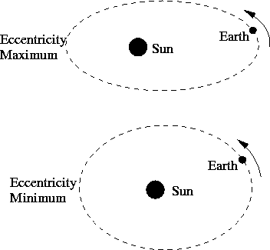Eccentricity
    - The shape of the earth’s __________________ changes from nearly __________________ to more ____________________ every 90,000-100,000 years
    - This change in _____________________ from the sun creates changes in earth’s climate.
    - This would create greater _______________________ in ______________________ temperatures.

  - 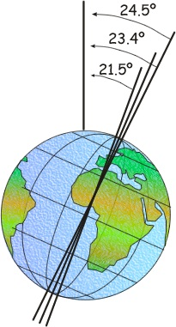Axial Tilt
    - The __________ of the earth’s axis is currently _____________
    - This angle ____________ from 22.1-24.5° every _____________________ years
    - Lower angles would cause warmer ___________________ and cooler _____________________
    - This would promote more _____________________ in winter and less snow ___________ in summer, causing ______ ______________ to form on the earth

  - 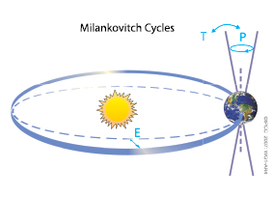Precession
    - As the earth rotates it ____________________ on its axis, just like a spinning ________ as it begins to slow down.
    - This cycle changes the __________ of the earth and coincides with ________ ________ cycles every 26,000 years.
    - This would also make the ______________________ ______________________ to what they are now

  - Solar Activity
    - The sun typically generates a ____________________ amount of _____________________ that makes its way to earth
    - Over time, slight variations in the amount of solar radiation may affect the __________________ ________________ ____________________________.
    - Scientists think that approximately __________ of the current warming of earth’s atmosphere is due to ________________________ solar activity
- Human Activity
  - We’ve already talked a lot about this, so let’s just say that we’re adding greenhouse gases to the atmosphere which are leading to an increase in global temperatures by trapping added heat

